Physics
John Dewey High School
Mr. Klimetz

The Orbital Kinematics of the Solar System
and the
Verification of Kepler’s Third Law

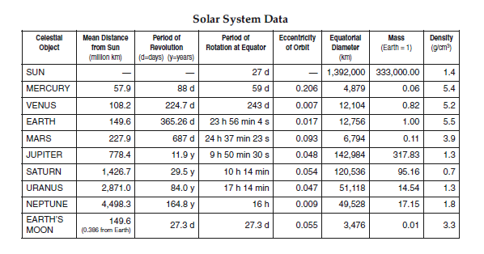

Based upon the information in the table above, verify Kepler’s Third Law by solving for the Kepler constant for each planet [in m³/s²]. Show all work.

Mercury
__________________________________________________________________
Venus
__________________________________________________________________
Earth
__________________________________________________________________
Mars
__________________________________________________________________
Jupiter
__________________________________________________________________
Saturn
__________________________________________________________________
Uranus
__________________________________________________________________
Neptune
__________________________________________________________________

