Fall Semester Regents Earth Science
John Dewey High School
Mr. Klimetz

Construction and Interpretation of
Weather Station Models

An Exercise in the Construction and Interpretation of Weather Station Models in Conformity with the ESRT

When you watch a weather report, the meteorologist describes the condition of the atmosphere at the present time, and makes a prediction about the future conditions that will exist in the atmosphere in the next 12 to 24 hours, and even for the next 5 days. Meteorologists get the data they need from synoptic weather maps - maps that show weather conditions from a number of weather stations around the country.

Individual weather stations report current conditions which are encoded on the map. This quick lab exercise will familiarize you with the information and method of encoding information on weather maps.

1. Make a list of all the atmospheric features a meteorologist would include in a careful description of current weather conditions:

2. Read Topics 13 and 14 on pages 509 and 510 in your text, and the “Weather Station Model” chart in the ESRT. Then, label what each feature on the station model drawn below represents:

65
003
.1
+ 34 /
82
10

3. There are probably a few things you thought might be included in the station model that aren’t included here, and there are probably a few things here that you never thought of.

4. Use your text index to find, read about, and define the following terms:

dew point:

relative humidity:

5. Find the long, narrow, vertical chart on your reference tables labeled “Pressure”.
What is the highest pressure (in millibars) labeled on that chart? _____________

What is the lowest pressure, in millibars, labeled on the chart?_____________

The two pressures above are the approximate high and low limits of atmospheric air pressures that are observed at the earth’s surface. Meteorologists take advantage of the limited range of observed pressures to encode them on the weather map.

The following explains how barometric pressures are encoded on a weather map.

Example 1: 1013.7 mb

a. Drop the decimal point ex. 10137
b. Report the last 3 digits ex. 137

Example 2: 989.6 mb

a. 9896 b. 896

6. Try encoding these: 1022.7 = _____________ 998.0 = ___________

Meteorologists encode the pressures that they report on their station models.

The following explains how barometric pressures are decoded when reading a weather map:

Example 1: 146

a. Replace the decimal point ex. 14.6

b. Place a “9”, then a “10”, in front of the coded number ex. 914.6 1014.6

c. Determine which of the 2 decoded pressures falls within the normal range of pressures at the earth’s surface (960 - 1040 mb).

ex. 914.6 is below the normal range, so 146 is the code for atmospheric pressure of 1014.6 mb.

Example 2: 972

a. 97.2 b. 997.2 or 1097.2 c. 997.2 or 1097.2

7. Try these: 127 = ___________ 865 = _____________ 001 = _____________

8. What is the decoded pressure on the station model drawn on page 1 of this lab? _____________

Good forecasting requires us to know what the barometer has been doing lately (rising, falling, or holding steady), and where the barometer is heading. This barometric pressure information is indicated as follows on the station model:

Example + 34 /
The “+” means that the pressure is higher now than it was 3 hours ago.
The “34” is code for 3.4 mb. This is how much higher the barometer is now than it was 3 hours ago.
The “/” means the barometer is still rising now. It is called the barometric trend.

Example - 27 \
The “-” means that the pressure is lower now than it was 3 hours ago.
The “27” is code for 2.7 mb. This is how much lower the barometer is now than it was 3 hours ago.
The “\” means the barometer is still falling now.

Example - 31 -
The “-” means that the pressure is lower now than it was 3 hours ago.
The “31” is code for 3.1 mb. This is how much lower the barometer is now than it was 3 hours ago.
The “ - ” means the barometer is holding steady now.

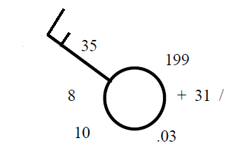9. An Example:
Wind direction? _________________

Wind speed? __________________

What is the temperature? _______ºF ________ ºC
(use the conversion chart in the reference tables)

What is the dew point? _______ºF ________ ºC

What is the present barometer reading at this station?____________

Is the barometer higher or lower than it was 3 hours ago? ____________

How much has the barometer changed in the last three hours?___________

What was the barometer reading 3 hours ago? ___________

What is the barometer doing NOW (rising or falling)?_____________

10. Another Example :

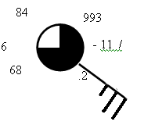Wind direction? _________________

Wind speed? __________________

What is the temperature? _______ºF ________ ºC
(Use the conversion chart in the ESRT)

What is the dew point? _______ºF ________ ºC

What is the present barometer reading at this station?____________

Is the barometer higher or lower than it was 3 hours ago? ____________

How much has the barometer changed in the last three hours?___________

What was the barometer reading 3 hours ago? ___________

What is the barometric trend here?_____________

What is the relative humidity of the air at this station? _____________ (This is a little tricky - you'll need to use both charts on page 12 of the ESRT. Use the Dewpoint Chart first, and work 'backwards' to find the difference between the dry bulb and the wet bulb. Use that information to find the RH on the Relative Humidity chart)

11. Draw a station model below indicating the following conditions.

Overcast skies, Temperature is 78ºF, dew point of 74ºF, barometer 3 hours ago 1003.6 mb, now 1000.1mb and falling. wind NNE* at 20 knots, visibility one half mile, light rain falling. Enter only the information that is used on an official station model (for instance, record only the numerical part of the temperature - not the °F label!)

*Remember: Winds are named for where they come from.

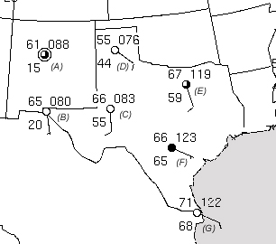

The image to the left is part of an actual synoptic weather map of the US from 11 March, 2003. It shows Texas and New Mexico, and parts of the surrounding states, Mexico, and the Gulf of Mexico. The stations have been labeled A - G for the purposes of this exercise.

Which station is reporting the lowest temperature? __________
What is that temperature?_________

Which station is reporting the highest dewpoint?________
What is that dewpoint?_________

Which station is reporting the highest air pressure?________
What is that pressure?_________

Which station is reporting the lowest air pressure?________
What is that pressure?_________

Which station probably has the highest relative humidity?_________
How do you know?___________________

Where is the air at station F coming from?_______________

Which stations are probably in the driest air mass?_________
How do you know?___________________

Where is the air at station B coming from?_______________

Consider the answers to the last 4 questions above, and make a clear, thoughtful statement about relative humidity of air masses that form over water and air masses that form over land.

